**Play and Learning Experience**

**We usually plan for children’s play and learning through observations. That is what you will do as an educator. However, for this placement course, we will use this planning form which was created for pre-planned play and learning experience.**

**Task: Create an experience/provocation, complete with an invitation that will enhance skill development.**

1. **Play experience:** 
   1. **Name of Experience:** Playing in nature
   2. **The age group this activity is geared towards:** This activity is created for children around 4 years old
   3. **Where will the experience be set up?**

The experience will be set outdoor, in a nearby garden or park with a small pond.

* 1. **Briefly explain the activity.**

Children will be asked to collect flowers, leaves, twigs, seeds, grasses, and weeds in different colored stones. They will be using small plastics spade to dig in the mud and unearth worms or insects. As suggested by Gill et al., (2019) the children will be wearing protective clothing throughout the activity such as gloves and rubberboots.

* 1. **What materials will you provide? Provide a picture or a detailed description of your invitation. (Make sure to reference any pictures that are not your own.)**

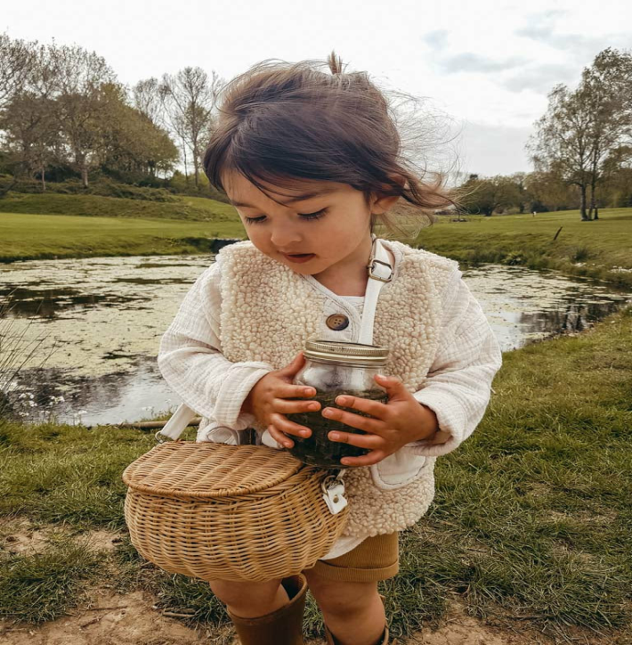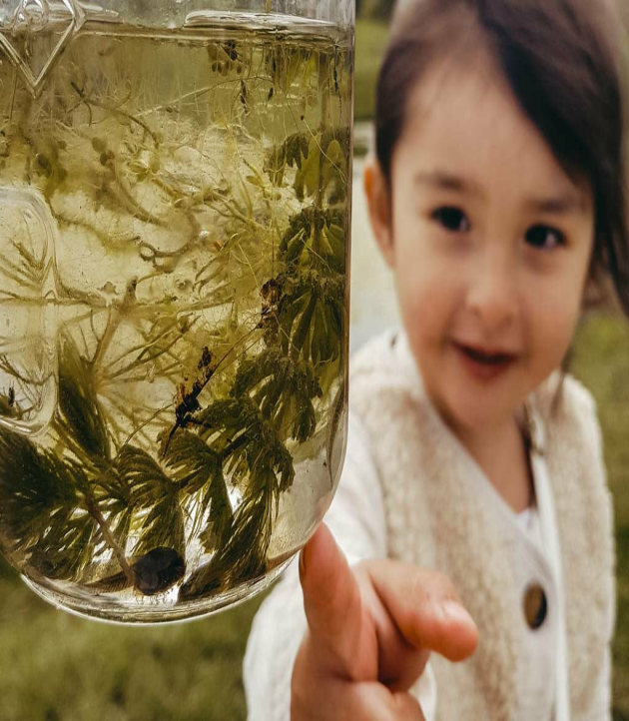

Source (Alexies, 2022)

The children will be provided with a basket, wide-necked bottles, protective clothing, plastic mugs, plastic spades, tweezers, and scissors. I will take them to a selected spot that will be covered with a trap (Gill et al., 2019) so that they are working in the shade and show them different shapes of leaves, flowers, and seeds and start collecting a few. I will also dig some portions of the mud and see if there are any insects or worms inside them. Children can do the same and we can build a small collection. Later we can compare the different shades of the leaves, the colors, and the shapes of flowers and grasses and bring them to the school. The children can observe how they change and dry over a while.

1. **What should you consider for COVID health and safety restrictions for this specific activity? (Refer to the covid module for help with this question.)**

According to the manual published by National Childhood Network, (2022), it is necessary to factor in Covid-19 restrictions in designing and conducting classroom activities. It is also necessary to move activities outdoors inside of indoors so that children get access to fresh air and social distancing can be more easily maintained. The best way to do so is by designing a play pod wherein the number of adults being in contact with children is limited, so contact teaching, support and interactions can take place.

While conducting this activity, I will ensure that a particular area is segregated and is covered by a trap either overhead or between two trees so that children are not exposed to too much heat, cold wind and can take shelter if it rains. They will also wear protective clothing whenever required for added protection.

1. **Domains and Skills: Select 2 or more key developmental domains that will support children’s learning. Identify the Domain and the Root Skills*.* (Please refer to the Continuum of Development in the ELECT for a guide and use the number of the skill in your answer.)**

2.6 Positive attitudes towards learning such as persistence, curiosity, engagement and mastery. They will be in a different environment, and learning new skills such as pulling out leaves, noticing the variety of flowers, working in wet mud (ELECT Framework, 2007)

Indicators of skills-accepting challenges and taking risks while learning. They may not like looking for worms or insects as they would be afraid or be disgusted with them, but they will learn to overcome fear later.

Interactions build on their curiosity to overcome fear.

4. Cognition (4.4,5,6, and 7) The children will have questions about nature, they will learn through observation of the variety of shapes and colors. They will be collecting the specimens and later noticing the change and reflecting on how it happened (ELECT Framework, 2007).

Indicators of skills – Asking questions, observing nature, collecting specimens, finding common colors, patterns, textures in nature, comparing different objects collected by others.

Interaction – Asking questions to me, interacting with others while collecting, showing their collections to others.

1. **Which of the 4 Foundations from How Does Learning Happen does this learning experience connect to and why? (It likely connects to more than one – explain all.)**

The four foundations are Belonging, Engagement, Well-being, and Expression (Ontario Public Service, 2014). The children will think of themselves in an alien environment when they first visit the garden or park, however, they will develop a sense of belonging as they engage with nature. They will observe that nature does not harm them, but they can learn a lot from it and this will increase their sense of wellbeing. Finally, by collecting materials from nature, they can express the reason why they picked a particular object.

**References**

Alexies. (2022, January 21). *13. open-ended play*. One Hundred Toys. <https://www.onehundredtoys.com/blogs/the-100/open-ended-play>

ELECT Framework. (2007). *Early Learning for Every Child Today A framework for Ontario early childhood settings*.

Gill, T., Power, M., &Brussoni, M. (2019). Risk-Benefit Assessment for Outdoor Play: A Canadian Toolkit. <https://childnature.ca/wp-content/uploads/2020/09/2019-11-03-CANADA-RBAT-ENGLISH-1.pdf>

National Childhood Network. (2021). Rethinking Outdoor Play During Covid 19. <https://www.fanshaweonline.ca/d2l/le/content/1258245/viewContent/10861767/View>

Ontario Public Service. (2014). *How Does Learning Happen? Ontario’s Pedagogy for the Early Years*. <https://files.ontario.ca/edu-how-does-learning-happen-en-2021-03-23.pdf>

Parenthub. (2014, August 13). *Literacy on the move*. <https://www.parenthub.com.au/news/kids-news/literacy-move/>